Part 1:ER diagram

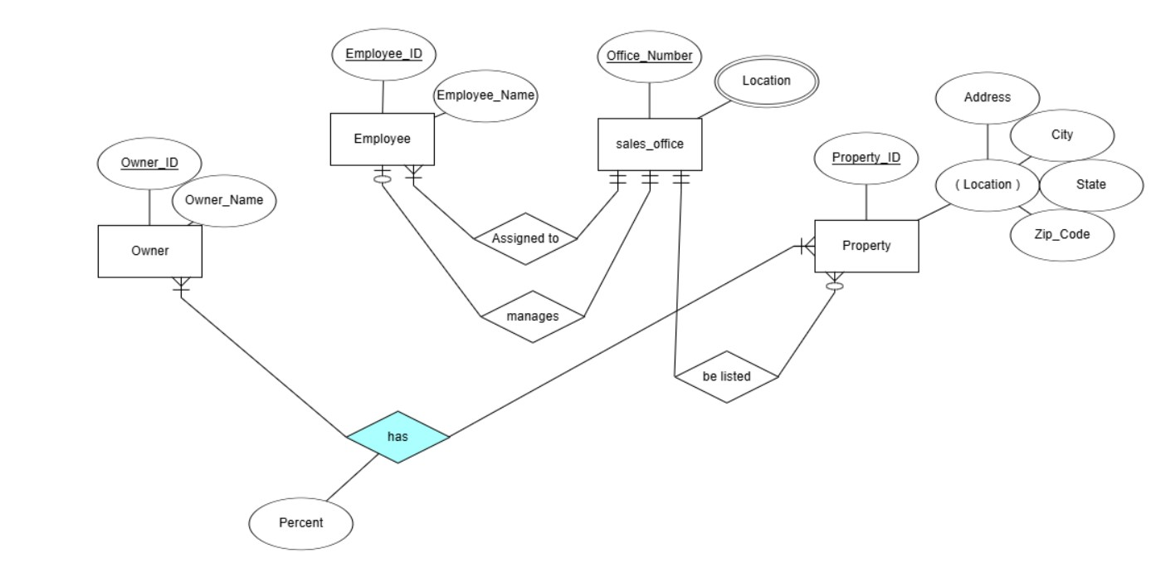

Part 2: Tables

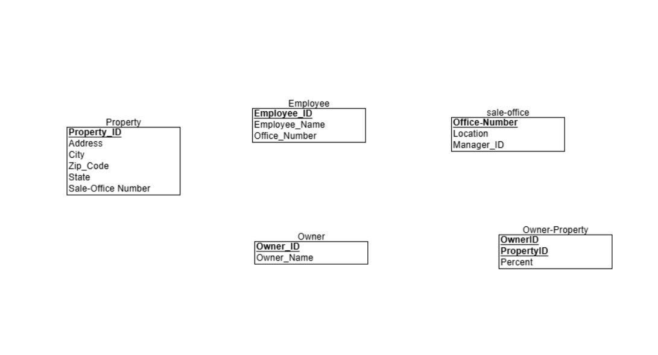Part 3: Queries

# **1.Create Database:**

Create DATABASE iti;



# **2.Create Table**

USE iti;

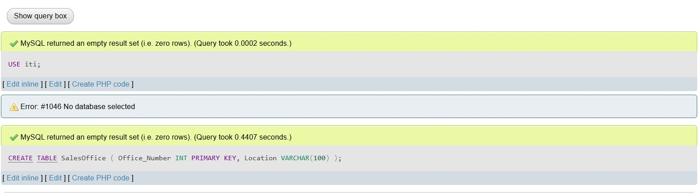CREATE TABLE SalesOffice ( Office_Number INT PRIMARY KEY, Location VARCHAR(100));

# **3.Drop Table**

use iti;

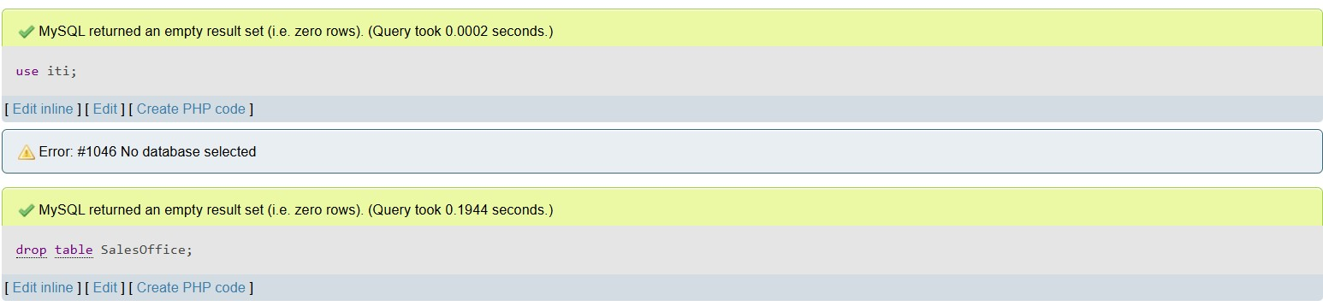drop table SalesOffice;

# **4.Alter Table**

use iti;

ALTER TABLE SalesOffice

ADD Phone_Number VARCHAR(15);

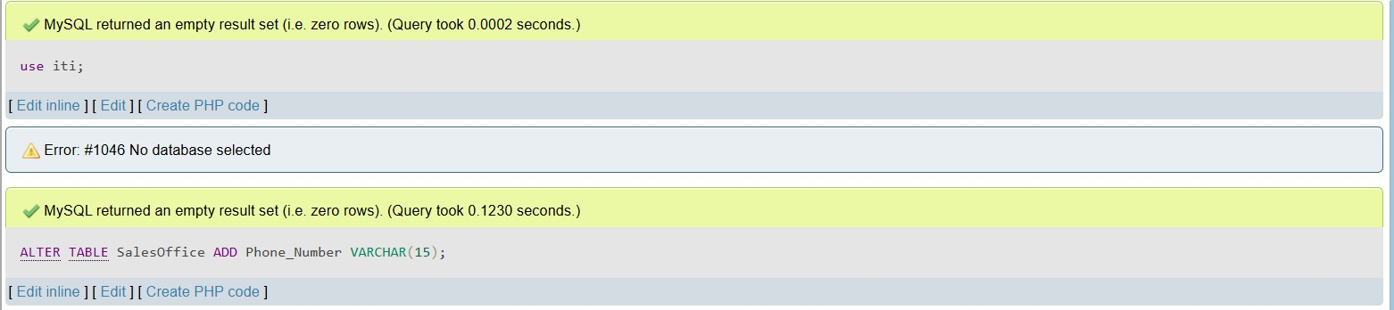

# **5.Show Current Date**

SELECT CURRENT_DATE;

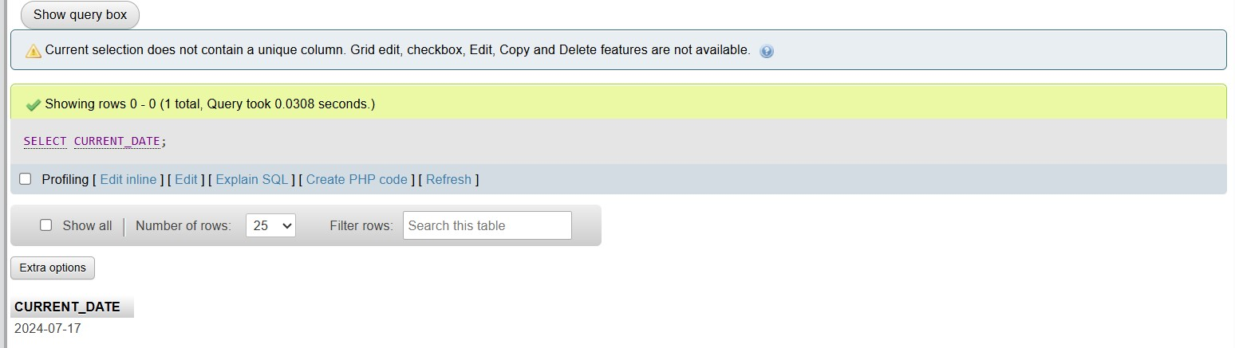

# **6.Show Databases**

SHOW DATABASES;

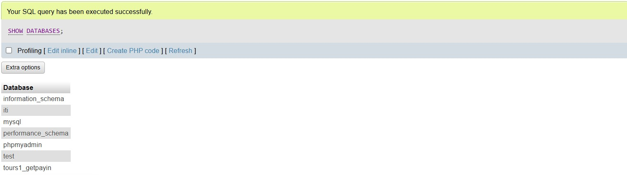

# **7.Show Versions**

SELECT VERSION();

